**DSA Practice Problems**

**Analysis of Algorithms**

**return total** in an interactive environment (like a Python shell, Jupyter notebook, or a script), it will not display the result unless you explicitly print it. So, use print when **calling the FUNCTION**

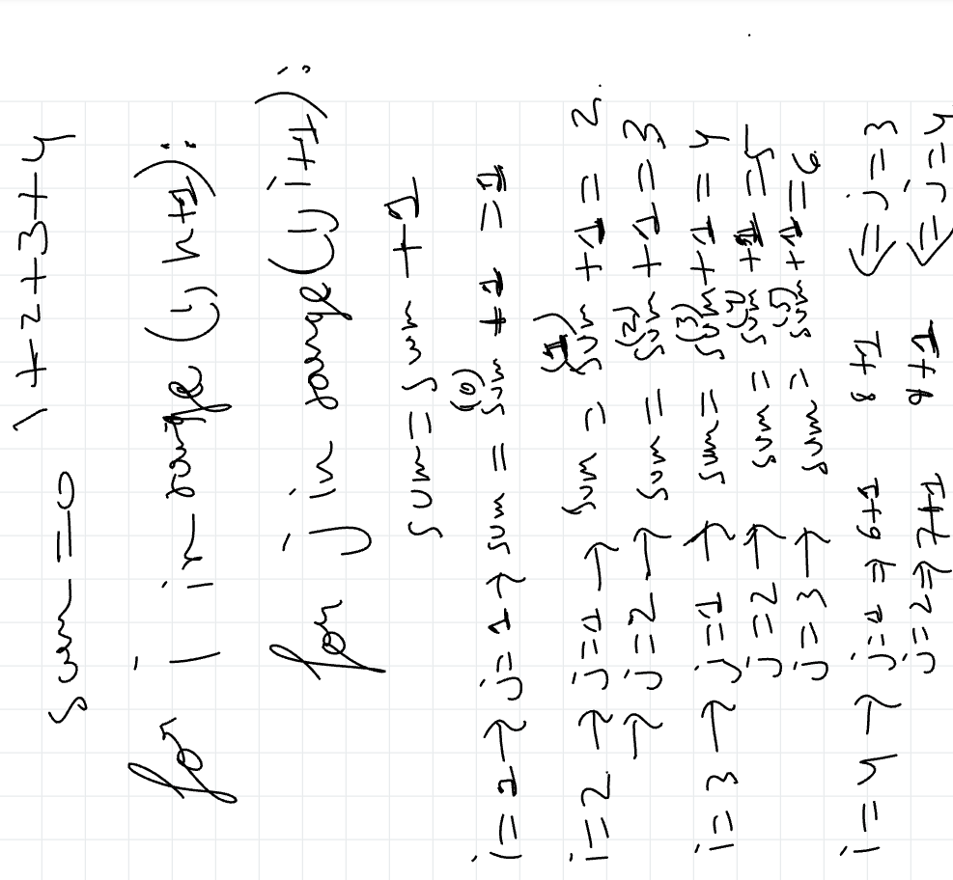

def natural_sum(num):

total=0

for i in range(1,n+1):

sum=sum+i

return total

print(natural_sum(10))

**Primitive and Non-Primitive understandings..**